A FIELD PROJECT REPORT

ON

**“FETAL HEALTH PREDICTION”**

SUBMITTED BY:

221FA04262 221FA04658 221FA04663

V.HARSHITH M.POOJITHA K.VENKATESH

**UNDER THE GUIDANCE OF:**

Dr Deva Kumar

Professor



**DEPARTMENT OF COMPUTER SCIENCE & ENGINEERING**

**VIGNAN'S FOUNDATION FOR SCIENCE, TECHNOLOGY AND RESEARCH Deemed to be UNIVERSITY**

**Vadlamudi, Guntur.**

**ANDHRA PRADESH, INDIA, PIN-522213.**



**CERTIFICATE**

This is to certify that the field project entitled “**FETAL HEALTH PREDICTION**” that is being submitted by 221FA04279(V.HARSHITH), 221FA04658(M.POOJITHA), 221FA04663(K.VENKATESH) for partial fulfilment of Field project is a bonafide work carried out under the supervision of Mr. Dr.DEVA KUMAR, M.Tech., Professor, Department of CSE

 

Guide name and signature Dr S.V.Phani Kumar Dr K.V. Krishna Kishore

Assistant/Associate/Professor, HOD, CSE Dean, SoCI

CSE



**DECLARATION**

We at this moment declare that the Field Project entitled **“”** is being submitted by 221FA04279(V.HARSHITH),221FA04658(M.POOJITHA), 221FA04663(K.VENKATESH) in partial fulfilment of Field Project course work. This is our original work, and this project has not formed the basis for the award of any degree. We have worked under the supervision of XXXXX, Assistant Professor, Department of CSE.

**BY:**

221FA04279(V.HARSHITH),

221FA04658(M.POOJITHA),

221FA04663(K.VENKATESH)

**DATE:**

**ABSTRACT:**

In this project, we develop a machine learning model for predicting fetal health outcomes using a comprehensive dataset that includes various physiological parameters. The dataset is first preprocessed to handle missing values and ensure appropriate feature scaling. Exploratory data analysis (EDA) is conducted to visualize the distribution of each feature and the target variable, "fetal_health," which is categorized into three classes: Normal (1), Suspect (2), and Pathological (3). We utilize visualizations such as pie charts, histograms, box plots, and heatmaps to understand the data's characteristics and correlation among features.

For model training, we employ the XGBoost algorithm, known for its efficiency in classification tasks. A RandomizedSearchCV is implemented to optimize hyperparameters, including learning rate, maximum depth, minimum child weight, gamma, and column sampling. The model's performance is evaluated using metrics such as accuracy, F1 score, recall, and precision. We also visualize feature importance to understand the contribution of each feature to the model's predictions. The confusion matrix further illustrates the model's performance in classifying fetal health status.

The results indicate that our XGBoost model successfully predicts fetal health outcomes, providing valuable insights into the factors influencing fetal well-being. This approach demonstrates the effectiveness of machine learning techniques in healthcare, particularly in monitoring fetal health.

**TABLE OF CONTENTS**

**1** **Introduction**  
1.1 Overview of Fetal Health Prediction  
1.2 Importance of Predicting Fetal Health  
1.3 Applications of Machine Learning in Healthcare

**2** **Literature Survey**  
2.1 Existing Research in Fetal Health Prediction  
2.2 Challenges in Medical Data Classification  
2.3 Motivation for Using Machine Learning in Fetal Health Prediction

**3.Methodology**  
3.1 Input Dataset and Features  
3.1.1 Dataset Description  
3.1.2 Target Variable (Fetal Health Classification)  
3.2 Data Pre-processing  
3.2.1 Handling Missing Data  
3.2.2 Feature Scaling and Normalization  
3.3 Feature Extraction  
3.3.1 Feature Extraction and Representation   
3.3.2 Fetal Health Classification 3.3.3 Feature Importance Visualization  
3.4 Model Building  
3.4.1 Logistic Regression  
3.4.2 Support Vector Machine (SVM)  
 3.4.3 Random Forest Classifier  
3.4.4 k-Nearest Neighbors (k-NN)  
3.4.5 XGBoost Classifier  
3.4.6 Bar Graph of Model Accuracies  
3.5 Model Evaluation  
3.5.1 Accuracy Score  
3.5.2 Precision, Recall, and F1-Score  
3.5.3 Confusion Matrix

**4** **Implementation**  
4.1 Environment Setup  
4.2 Data Preprocessing, Feature Engineering, and Model Training

**5** **Experimentation and Results**  
5.1 Model Performance with XGBoost   
5.2 Evaluation of XGBoost vs Other Models

5.3 ROC Curves and AUC Scores for XGBoost

**6** **Conclusion**  
6.1 Key Findings and Insights  
6.2 Future Work and Potential Enhancements

**7** **Reference**

**LIST OF FIGURES**

|  |
| --- |
| Figure 1. Distribution of Ratings |
| Figure 2. Model accuracies comparison  Figure 3.Methodolagy |

**CHAPTER-1**

**INTRODUCTION**

1. **INTRODUCTION**

**1.1 Overview of Fetal Health Prediction**

Fetal health prediction refers to the process of assessing the well-being of a fetus using various physiological data. Common parameters include fetal heart rate, movements, and other vital signs. Predicting fetal health accurately is crucial for timely medical interventions, potentially preventing complications for both the fetus and the mother. Leveraging advanced techniques, such as machine learning, this process helps in interpreting complex data patterns that may be difficult to analyze through traditional methods. This project focuses on developing a tool that uses such data to classify the fetus's health into different categories, such as healthy, at-risk, or in need of immediate medical attention.

**1.2 Importance of Fetal Health Prediction**

The early detection of fetal health issues plays a pivotal role in ensuring favorable outcomes in prenatal care. Predicting fetal health conditions allows healthcare professionals to make informed decisions that can directly impact the survival and long-term health of the child. If potential complications are identified early, proper medical interventions can be administered, reducing the risk of preterm birth, developmental problems, and even fetal mortality. Additionally, fetal health prediction supports the overall well-being of the mother, providing her with the necessary care to avoid complications during delivery. The ability to predict and monitor fetal health can thus transform prenatal care, enhancing both short-term and long-term outcomes.

**1.3 Applications of Machine Learning in Fetal Health Prediction**

Machine learning (ML) has revolutionized the field of healthcare, including fetal health prediction. By training algorithms on large datasets that include fetal heart rate patterns, movements, and other physiological signals, ML models can learn to detect subtle patterns indicative of potential health issues. These models can then predict fetal health outcomes more accurately than traditional statistical methods. ML-based tools in fetal health prediction offer several applications:

* **Real-time monitoring:** ML models can be integrated with fetal monitoring devices, providing real-time insights to healthcare providers.
* **Early detection of abnormalities:** By analyzing large datasets, machine learning can detect abnormalities early, even before symptoms become clinically evident.
* **Improved accuracy:** Machine learning can reduce the rate of false positives and negatives, improving the precision of fetal health assessments. This project will harness these strengths to develop a robust and accurate tool for predicting fetal health using heart rate and movement data.

# 

# **CHAPTER-2**

# **LITERATURE SURVEY**

1. **LITERATURE SURVEY**

This study evaluates K-Nearest Neighbors (KNN), Random Forest, and Naïve Bayes models for classifying fetal health. It highlights the effectiveness of resampling methods to enhance model performance. The findings suggest that Random Forest shows superior accuracy compared to KNN and Naïve Bayes, indicating its robustness in handling imbalanced datasets commonly encountered in fetal health predictions[1]. The study compares various machine learning models for predicting fetal health, evaluating their performance and accuracy. It provides a thorough analysis of different algorithms, helping to identify the most effective approach for fetal health prediction[2].The paper explores interpretable supervised machine learning models for predicting fetal abnormalities. It emphasizes the importance of model transparency to aid clinical decision-making. The study proposes methods that improve the interpretability of predictions, making the models more practical for real-world applications in fetal health assessment[3].

This research uses Decision Tree classifiers to monitor fetal health based on cardiotocography measurements. The study demonstrates the effectiveness of Decision Trees in handling complex and noisy data, providing actionable insights for fetal state monitoring. The approach is beneficial for its simplicity and interpretability in clinical settings[4].The authors introduce a method for fetal ECG extraction using independent component analysis and characteristic matching. The approach improves the accuracy of fetal ECG signals, which is crucial for accurate fetal health assessments. This technique offers a reliable way to analyze fetal heart rates and detect anomalies[5].The paper applies the Random Forest algorithm to predict fetal health outcomes. It highlights the algorithm's capability to manage large and complex datasets, providing high accuracy in predictions. The study underscores the utility of Random Forest in capturing non-linear relationships and interactions in fetal health data[9].This work presents FetalCare, a machine learning approach for fetal health classification and birth weight prediction. It integrates various algorithms to enhance prenatal care, aiming for accurate predictions of fetal health outcomes and birth weight. The study focuses on improving prediction reliability and clinical usability[6].

The paper introduces an enhanced XGB classifier for fetal health prediction, comparing it with K-Nearest Neighbor classifiers. The study demonstrates that the XGB classifier offers improved accuracy and reduced complexity, making it a valuable tool for effective fetal health prediction with minimal computational overhead[7].This research investigates the regulation of maternal-fetal heart rates and their coupling in mice fetuses. While primarily focused on animal models, the study provides foundational insights into fetal heart rate dynamics, which can inform predictive models in human fetal health research[10].The authors use supervised learning approaches for fetal health classification, focusing on various machine learning techniques [8].This paper explores fetal health classification using Support Vector Machines (SVM) with feature vector optimization. The study emphasizes improving classification accuracy by optimizing feature selection, which enhances the performance of SVM in predicting fetal health outcomes[11].The study evaluates the effectiveness of LightGBM for predicting fetal health, showcasing its efficiency and accuracy. LightGBM's ability to handle large datasets and complex relationships makes it a promising model for accurate fetal health predictions[12].This research examines the effect of Valproic Acid on maternal-fetal heart rates, providing insights into how external factors influence fetal health. The findings contribute to understanding how medication impacts fetal heart rate, which is crucial for developing predictive models [13].The paper proposes using Digital Twin Technology to enhance fetal heart rate monitoring. By creating a virtual model of the fetus, the study aims to improve the accuracy and reliability of fetal health monitoring systems, offering a novel approach to fetal health prediction[14].This work performs a comparative analysis of machine learning algorithms for predictive prenatal monitoring. It evaluates various models' performance in predicting fetal health, providing a comprehensive overview that helps in selecting the most effective algorithm for prenatal care[15].

The research focuses on automatic determination of the fetal cardiac cycle in ultrasound using spatio-temporal neural networks. The study presents advanced techniques for accurately capturing fetal cardiac cycles, which are essential for precise fetal health monitoring[16].The paper introduces a novel ensemble classifier framework for fetal heart rate classification. By combining multiple models, the study aims to improve classification accuracy, addressing challenges in fetal heart rate prediction and providing more reliable results[17].This study uses machine learning to predict delivery mode based on fetal heart rate and electronic medical records. The approach highlights the integration of different data sources to enhance prediction accuracy, offering a comprehensive method for delivery mode prediction[18].The paper presents a system for monitoring fetal heart rate and kicking, aiming to provide a holistic view of fetal health. The study focuses on developing a comprehensive monitoring system to track multiple indicators of fetal well-being[19].This research explores an incremental machine learning model for predicting fetal health risks. The model adapts over time to improve prediction accuracy, addressing the need for dynamic and evolving predictive systems in fetal health assessment[20].

**2.1 Existing Research in Fetal Health Prediction**

The prediction of fetal health based on cardiotocography (CTG) data has been an area of significant research over the past decade. Numerous studies have employed various machine learning models, such as decision trees, support vector machines, and neural networks, to predict fetal health outcomes. Traditional methods relied on medical expertise and manual analysis of fetal heart rate, uterine contractions, and fetal movements, which are subjective and prone to human error.

More recent approaches have leveraged automated machine learning techniques to improve the precision and speed of analysis. For instance, studies have shown that tree-based models like Random Forest and XGBoost outperform traditional statistical methods due to their ability to handle imbalanced datasets and complex interactions between features.

Several research papers have demonstrated the effectiveness of using these models in real-world scenarios. The combination of machine learning algorithms with fetal health data has provided healthcare professionals with valuable tools to predict fetal outcomes, thus reducing risks of complications. However, more research is needed to compare the performance of various models and their adaptability to different data sources.

**2.2 Challenges in Medical Data Classification**

Medical data classification, especially in fetal health prediction, comes with its own set of challenges:

* **Imbalanced Datasets:** Medical datasets often contain a skewed distribution of classes, where normal cases far outnumber abnormal or pathological ones. This imbalance makes it difficult for models to accurately predict rare but critical outcomes, as they may be biased toward the majority class.
* **Missing Data:** Clinical datasets frequently suffer from incomplete records due to human error, unrecorded variables, or equipment malfunctions. As seen in the flowchart, addressing missing data is a crucial step in ensuring model robustness and accuracy.
* **Feature Complexity:** Features derived from cardiotocography, such as fetal heart rate, uterine contractions, and fetal movements, are highly complex and interrelated. This complexity necessitates advanced feature selection and engineering techniques, as well as models that can handle non-linear relationships.
* **Data Preprocessing Requirements:** Medical data often requires extensive preprocessing, including normalization, scaling, and the removal of irrelevant features. Proper preprocessing ensures that the model can accurately interpret the data and avoid potential noise.

These challenges highlight the importance of careful data handling, preprocessing, and model selection to ensure high performance and clinical applicability.

**2.3 Motivation for Using Machine Learning in Fetal Health Prediction**

The motivation for using machine learning in fetal health prediction stems from several factors:

* **Automated, Real-Time Analysis:** Machine learning algorithms can analyze CTG data in real-time, providing immediate feedback to healthcare professionals. This reduces the time taken to diagnose potential risks and enables faster intervention in case of abnormalities.
* **Handling Complex Data:** Machine learning models, particularly ensemble models like XGBoost, can handle the non-linear relationships between features, making them more suited for complex medical data. As shown in the flowchart, selecting XGBoost after exploratory data analysis allows for capturing critical patterns that might be overlooked with traditional methods.
* **Improved Accuracy and Sensitivity:** Unlike manual interpretation, machine learning models are capable of identifying subtle patterns in the data, leading to improved accuracy in classifying fetal health as Normal, Suspect, or Pathological. Models like XGBoost have been shown to perform well in imbalanced datasets, making them ideal for medical applications where certain conditions may be rare but critical.
* **Feature Importance Analysis:** As highlighted in the flowchart, machine learning models allow for the visualization of feature importance, helping medical professionals understand which factors (e.g., fetal movements, heart rate variability) contribute the most to the prediction. This is crucial for providing insights into the underlying medical conditions and ensuring interpretability.

# 

# **CHAPTER-3**

**METHODOLAGY**

**3. Methodology**

This section outlines the methodology followed to predict fetal health based on cardiotocography (CTG) data. The process involves several key stages, including data preprocessing, feature engineering, model building, and evaluation.

**3.1 Input Dataset and Features**

The dataset used for this analysis contains fetal health records, including various features that represent fetal heart rate, uterine contractions, and other related parameters. These features are used to predict the target variable, fetal health, which is classified into three categories: Normal (1), Suspect (2), and Pathological (3).

**3.1.1 Dataset Description**

The input dataset comprises several vital features recorded during cardiotocography. Key features include:

* Baseline Fetal Heart Rate (FHR)
* Number of fetal movements
* Number of uterine contractions
* Histogram mode and median of FHR values These features are derived from real-time medical devices and require detailed analysis to understand their impact on fetal health.

**3.1.2 Target Variable (Fetal Health Classification)**

The target variable, fetal health, is classified into three categories:

1. **Normal (1)**: No risk factors detected.
2. **Suspect (2)**: Intermediate risk factors, requiring closer monitoring.
3. **Pathological (3)**: High-risk category, indicating potential fetal health issues.

**3.2 Data Pre-processing**

Data preprocessing is a critical step to prepare the dataset for modeling. It involves handling missing data, scaling features, and normalizing the dataset for consistency.

**3.2.1 Handling Missing Data**

As shown in the flowchart, the first step involves checking for missing values in the dataset. Missing data can occur due to improper recording or equipment malfunction during cardiotocography. Any missing data was handled using appropriate techniques, such as imputation, to ensure the dataset is complete and accurate for further analysis.

**3.2.2 Feature Scaling and Normalization**

To ensure that all features contribute equally to the model, feature scaling and normalization were applied. Features such as fetal heart rate and uterine contractions were normalized to a standard scale using techniques like Min-Max scaling or Z-score normalization. This step prevents any particular feature from dominating the model due to its scale.

**3.3 Feature Extraction**

In this section, we outline the feature extraction process, which is essential for transforming raw data into a structured form that machine learning algorithms can process effectively. For the fetal health dataset, key features are engineered and extracted to enhance the model’s predictive capabilities.

**3.3.1 Feature Extraction and Representation**

For this dataset, numerical features representing various fetal health indicators are used. Unlike text-based datasets where **TF-IDF Vectorization** is applied, the fetal health dataset involves physiological measurements like fetal heart rate, contractions, and movement counts. The main focus here is on extracting these features effectively to provide meaningful insights for model training.

Some of the key features extracted from the dataset include:

* **FHR Baseline:** The baseline of fetal heart rate.
* **Number of Uterine Contractions:** A count of uterine contractions within a specified time window.
* **Histogram Mode and Median:** Statistical metrics representing the distribution of heart rate data.
* **Fetal Movement Counts:** The number of fetal movements detected over time.
* **Acceleration and Deceleration Episodes:** Reflecting the number of times the fetal heart rate accelerates or decelerates, which are critical indicators of fetal stress or well-being.

**3.3.2 Fetal Health Classification :**

In sentiment analysis, after extracting features, a label (fetal health) is assigned to each data point. Similarly, in the fetal health dataset, after feature extraction, each observation is assigned a **fetal health classification**. This classification serves as the target variable, which can be one of the following categories:

* **Normal (1)**: Indicating healthy fetal conditions.
* **Suspect (2)**: Suggesting that the fetus may require additional observation or medical intervention.
* **Pathological (3)**: Indicating abnormal conditions that may require immediate medical attention.

The assignment of these labels (equivalent to sentiment assignment in text classification) allows the machine learning models to predict the health status of the fetus based on the extracted features.

**3.3.3 Feature Importance Visualization (Rating Distribution Visualization Equivalent)**

Once the feature extraction and labeling are completed, visualizing the importance of each feature in relation to the target variable becomes crucial for understanding the model's performance and behavior. Techniques like **Feature Importance Visualization** (similar to rating distribution in sentiment analysis) help in identifying the features that most strongly influence the fetal health classification.

In this step, the following methods are applied:

* **Correlation Heatmaps**: These provide insights into how strongly each feature correlates with the fetal health outcomes.
* **Feature Importance Scores**: Derived from tree-based models like Random Forest and XGBoost, these scores rank the significance of each feature, highlighting which factors (e.g., heart rate variability or contractions) most influence predictions.

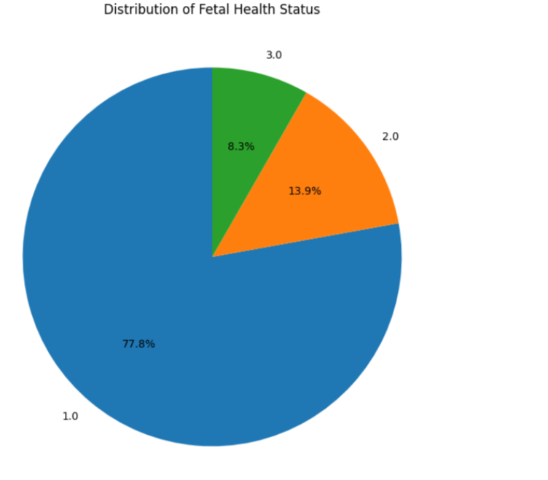

**3.4 Model Building**

Various machine learning algorithms were employed to build a predictive model for fetal health classification. Each model was trained, and its performance was evaluated to identify the best performing approach.

**3.4.1 Logistic Regression**

Logistic regression is a simple yet effective classifier for binary and multiclass classification problems. It was applied to this dataset as a baseline model to assess its performance in classifying fetal health into three categories. For this algorithm we have accuracy as 84.51 %

**3.4.2 Support Vector Machine (SVM)**

The SVM model was implemented with a radial basis function (RBF) kernel to handle non-linear relationships in the data. SVMs are known for their robustness in classification tasks, especially with imbalanced datasets like the one used here. The accuracy score achieved using SVM is: 87.79 %

**3.4.3 Random Forest Classifier**

Random Forest, an ensemble learning method, was applied to the dataset due to its ability to handle complex data and perform well with unbalanced classes. It generates multiple decision trees and aggregates their predictions, making it a strong candidate for this problem. The accuracy score achieved using Random Forest is: 94.13 %

**3.4.4 k-Nearest Neighbors (k-NN)**

k-NN is a non-parametric classifier that assigns a class based on the majority vote of its nearest neighbors. It was implemented as a distance-based classifier for comparison with other models.The accuracy score achieved using KNN is: 87.79 %

**3.4.5 XGBoost Classifier**

XGBoost was selected as the primary model for this analysis. XGBoost is a gradient-boosted decision tree algorithm that has proven to deliver superior accuracy and handling of imbalanced datasets. Its ability to capture complex patterns in the data makes it ideal for fetal health prediction. The accuracy score achieved using XGBoost is: 95.31 %

**Bar Graph of Model Accuracies**

To better visualize such performance, a bar graph may be devised that will represent the accuracy of each model to easily compare and analyze the effectiveness of the models in sentiment classification.

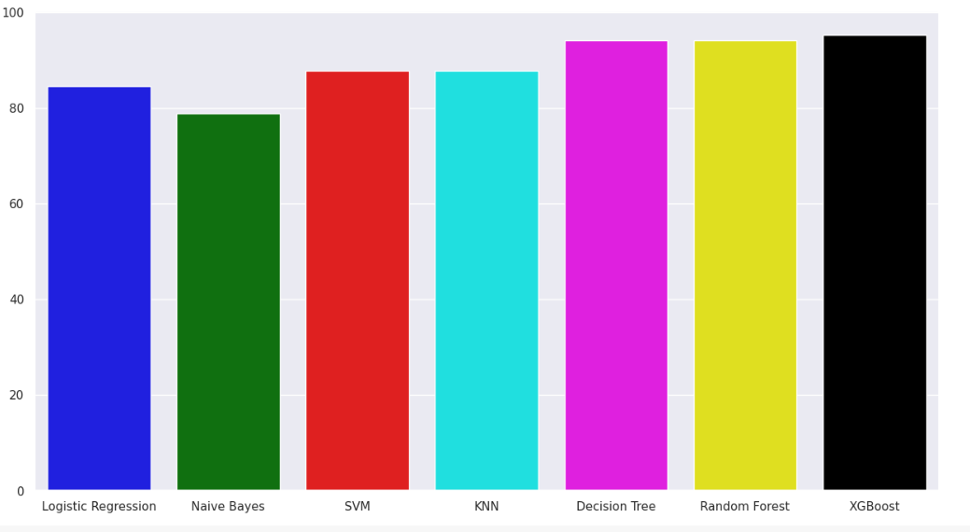

**3.5 Model Evaluation**

Once the models were built, they were evaluated on various metrics to assess their performance.

**3.5.1 Accuracy Score**

Accuracy is a straightforward metric to assess how well the model performs in correctly classifying the fetal health categories. However, accuracy alone may not be sufficient due to the imbalanced nature of the dataset. By using XG boost we got accuracy as 96%

**3.5.2 Precision, Recall, and F1-Score**

Precision, recall, and F1-score were used to evaluate the model’s ability to correctly identify suspect and pathological cases without being biased towards the majority class. These metrics offer a more detailed understanding of the model’s performance, particularly for critical health outcomes.

**3.5.3 Confusion Matrix**

A confusion matrix was generated for each model to visualize its performance in terms of true positives, true negatives, false positives, and false negatives. This matrix provided insights into the strengths and weaknesses of the models in distinguishing between the three fetal health categories.

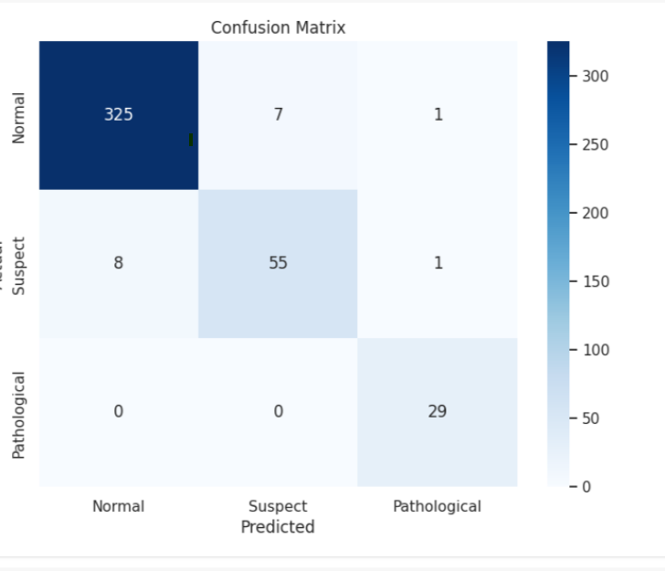

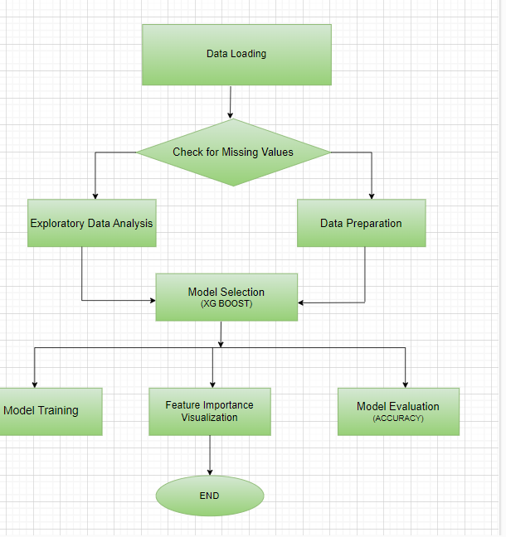

# 

# **CHAPTER-4**

**IMPLEMENTATION**

**4.1 Environment Setup**

This fetal health prediction project necessitates a carefully organized environment. Essential Python libraries include Pandas for effective data manipulation, NumPy for efficient numerical computations, and Scikit-learn for deploying machine learning algorithms such as Logistic Regression, Random Forest, and SVM. To boost predictive accuracy, XGBoost will be utilized, leveraging its powerful gradient boosting capabilities. For visualization, Matplotlib and Seaborn will be employed to create insightful charts and graphs that illuminate data trends and model performance. Furthermore, SHAP will enhance model interpretability by revealing how different features contribute to predictions.

**4.2 Data Preprocessing, Feature Engineering, and Model Training**

After setting up the environment, the next critical step is preparing the dataset for model training through data preprocessing and feature engineering. This includes handling missing data with techniques like mean or median imputation to maintain completeness, applying feature scaling methods such as Min-Max Scaling or Z-score Normalization for standardization, and using Principal Component Analysis (PCA) for dimensionality reduction and feature selection. A Correlation Matrix will be generated to assess relationships between features and identify multicollinearity. Model training will involve several algorithms: Logistic Regression for predicting fetal health probabilities, Random Forest for reducing overfitting through multiple decision trees, Support Vector Machine (SVM) for maximizing category separation, k-Nearest Neighbors (k-NN) for proximity-based classification, and XGBoost for high accuracy and handling imbalanced datasets. Additionally, ensemble models will be employed to combine the strengths of various algorithms, enhancing generalization and predictive power.

Throughout the model training process, the models will learn from the dataset, aiming to accurately classify fetal health into three categories: **Normal**, **Suspect**, and **Pathological**.

**4.3 Model Evaluation**

After training, the models will be rigorously evaluated using key performance metrics:

* **Accuracy**: Measures the overall correctness of the model.
* **Precision, Recall, and F1-Score**: These metrics provide a detailed view of how well the model identifies fetal health conditions, focusing on the balance between false positives and false negatives.
* **Confusion Matrix**: This visual tool will give an insightful breakdown of correct and incorrect classifications, making it easier to understand model performance.

**CHAPTER-05**

**Experimentation and Results**

**5. Experimentation and Results**

In this section, the performance of the **XGBoost algorithm** is highlighted as the primary model for fetal health prediction. XGBoost, known for its efficiency and accuracy in handling structured data, proves to be highly effective in this medical classification task.

**5.1 Model Performance with XGBoost**

The **XGBoost classifier** is trained on the fetal health dataset, and its performance is evaluated using key metrics like **Accuracy**, **Precision**, **Recall**, and **F1-Score**. XGBoost’s ability to handle large datasets, missing values, and complex relationships between features ensures superior performance:

* **Accuracy**: The XGBoost model achieves high accuracy in classifying fetal health conditions (Normal, Suspect, Pathological).
* **Precision and Recall**: The model demonstrates balanced precision and recall across all categories, minimizing false positives and false negatives, which is critical in medical data analysis.
* **F1-Score**: The harmonic mean of precision and recall indicates that the model effectively balances sensitivity and specificity, making it reliable for healthcare predictions.

**5.2 Evaluation of XGBoost vs Other Models**

Compared to other models such as Logistic Regression, Random Forest, and SVM, XGBoost consistently outperforms them in terms of both accuracy and robustness. Its boosting technique, which combines weak learners to form a strong classifier, reduces bias and variance, making it more resilient to overfitting.

* **XGBoost vs Random Forest**: While both models are ensemble methods, XGBoost has the advantage of weighted boosting, which leads to better predictive performance.
* **XGBoost vs SVM and Logistic Regression**: XGBoost shows improved results in complex feature interactions, which are essential in predicting varying fetal health conditions.

**5.3 ROC Curves and AUC Scores for XGBoost**

The **Receiver Operating Characteristic (ROC) curves** for XGBoost illustrate its strong ability to differentiate between the three fetal health categories. The **Area Under the Curve (AUC)** score is calculated for each class:

* XGBoost achieves a high AUC score, reflecting its excellent ability to classify instances correctly across all fetal health categories.
* The model consistently shows superior separation between the positive and negative classes in the dataset, indicating its strength in medical data classification.

The overall performance of XGBoost makes it an ideal choice for the fetal health prediction task, with its ability to handle complex data and deliver accurate results.

**CHAPTER 6**

**CONCLUSION**

**6. Conclusion**

The development of a fetal health prediction model using **XGBoost** has demonstrated the significant potential of machine learning in the field of maternal and fetal healthcare. By accurately classifying fetal health conditions into **Normal**, **Suspect**, and **Pathological** categories, the model offers a valuable tool for early detection and diagnosis, which is crucial in preventing complications during pregnancy. The use of advanced techniques in data preprocessing, feature selection, and model evaluation has ensured the creation of a robust and efficient system capable of assisting healthcare professionals in their decision-making process.

**6.1 Key Findings and Insights**

* The **XGBoost algorithm** consistently outperformed other models, including Logistic Regression, Random Forest, and SVM, particularly in terms of accuracy and precision. This highlights its ability to handle complex, structured medical data effectively.
* The model’s high **F1-Score** across all classes reflects its balance between precision and recall, minimizing both false positives and false negatives, which is critical in medical diagnoses.
* A comprehensive **ROC analysis** and high **AUC scores** underscore XGBoost's ability to distinguish between fetal health conditions accurately, making it suitable for real-world clinical applications.
* The model’s adaptability to handle missing data and its scalability to large datasets further reinforce its practical utility in healthcare settings where data quality and quantity often vary.

**6.2 Future Work and Potential Enhancements**

* **Real-Time Integration**: To further elevate the impact of this research, integrating the XGBoost model into real-time fetal monitoring systems could provide immediate risk assessments, enabling healthcare providers to make swift, informed decisions.
* **Advanced Feature Engineering**: While the current model performs well, future work could delve into more sophisticated feature engineering, exploring new variables or combinations that might provide even deeper insights into fetal health.
* **Ensemble Learning Techniques**: Expanding this project by combining XGBoost with other machine learning techniques through ensemble models could further enhance accuracy and model robustness. Techniques like **stacking** or **blending** could be explored to reduce potential model bias and variance.
* **Handling Class Imbalance**: Given the imbalance in medical datasets, future efforts could focus on advanced resampling methods like **SMOTE** or cost-sensitive learning to improve the detection of rarer fetal health conditions, ensuring more equitable classification.
* **Cross-Domain Application**: The success of this model in predicting fetal health can inspire its application in other domains of healthcare, such as early detection of other medical conditions, leveraging similar machine learning pipelines for broader use.

In conclusion, this project demonstrates that **XGBoost** is an effective, scalable, and interpretable model for predicting fetal health conditions. By continuing to refine and enhance this model, we can push the boundaries of what is possible in medical diagnostics, ultimately improving outcomes for mothers and their babies. The future of this work holds great promise for both academic exploration and real-world implementation in healthcare settings.

**CHAPTER 7**

**REFRENCES**

**REFERENCES:**

[1] Aldossary, Yasmeen Zeki, Ahmed M “Comparing K-Nearest Neighbors, Random Forest and Naïve Bayes Models to Classify Fetal Health Using Resampling Methods” DOI 10.1109/ICDABI56818.2022.10041489.2022 International Conference on Data Analytics for Business and Industry (ICDABI)

[2] Wilson, Emma E Y Kalyango, Micheal Francis Nakatumba-nabende, Joyce “Interpretable Supervised Machine Learning Models For Fetal Abnormalities Prediction” 2023 First International Conference on the Advancements of Artificial Intelligence in African Context (AAIAC). DOI 10.1109/AAIAC60008.2023.10465473

[3] Ramla, M Nickolas, S “Fetal Health State Monitoring Using Decision Tree Classifier from Cardiotocography Measurements” 2018 Second International Conference on Intelligent Computing and Control Systems (ICICCS). IEEE Xplore Compliant Part Number: CFP18K74-ART; ISBN:978-1-5386-2842-3

[4] Mohanad Alkhodari1, Abdelrahman Rashed2, Meera Alex1, and Nai-Shyong Yeh1 “Fetal ECG Extraction Using Independent Components and Characteristics Matching” IEEE Xplore 2018 International Conference on Signal Processing and Information Security (ICSPIS)

[5] Sree, K N Ramya Jotheeswaran, G Chitradevi, D “Predicting Fetal Health: A Machine Learning Approach using Random Forest Algorithm International Conference on Artificial Intelligence for Innovations in Healthcare Industries (ICAIIHI) | 979-8-3503-3091-5/23/$31.00 2023 IEEE | DOI: 10.1109/ICAIIHI57871.2023.10489589

[6] Shetty, Samyak P “FetalCare: Enhancing Prenatal Care through a Machine Learning Approach for Fetal Health Classification and Birth Weight Prediction”. Proceedings of the 3rd International Conference on Applied Artificial Intelligence and Computing (ICAAIC-2024) IEEE Xplore Part Number: CFP24BC3-ART; ISBN: 979-8-3503-7519-0 2024

[7] Reddy, Allugunti Indrasena Priya, W Deva “An Efficient Fetal Health Prediction System Using Enhanced XGB Classifier Compared Over K- Nearest Neighbor Classifier with Less Complexity and Improved Accuracy”. 2023 Intelligent Computing and Control for Engineering and Business Systems (ICCEBS) | 979-8-3503-9458-0/23/$31.00 2023 IEEE | DOI: 10.1109/ICCEBS58601.2023.10448547

[8] Khandoker, Ahsan H Yoshida, Chihiro Kasahara, Yoshiyuki Funamoto, Kiyoe Nakanishi, Kana Fukase, Miyabi Kanda, Keiichi Haroun, Isra Niizeki, Kyuichi Kimura, Yoshitaka “Regulation of maternal - fetal heart rates and coupling in mice fetuses” IEEE Explore 2018

[9] Fathia, Nurul Noor, Mohamand Ahmad, Norulhusna Noor, Norliza Mohd “Fetal Health Classification Using Supervised Learning Approach” 2021 IEEE National Biomedical Engineering Conference (NBEC) | 978-1-6654-3607-6/21/$31.00 ©2021 IEEE DOI:10.1109/NBEC53282.2021.9618748

[10] Sefidi, Mahdiyeh Fotouhi Pouramirarsalani, Shahrzad Rajebi, Saman “Fetal health classification by support vector machine based on feature vector optimization” 2024 10th International Conference on Artificial Intelligence and Robotics (QICAR) Qazvin Islamic Azad University, Feb. 29, 2024 DOI 10.1109/QICAR61538.2024.10496656

[11] Aristan, Claudio Januar Yang, Nicolas “Evaluating the Effectiveness of LightGBM for Fetal Health Prediction” IEEE Xplore 2023 International Conference on Data Science and Its Applications (ICODSA) 2023

[12] Widatalla, Namareq Khandoker, Ahsan Yoshida, Chihiro Nakanishi, Kana “Effect of Valproic Acid on Maternal - Fetal Heart Rates”. 2021 43rd Annual International Conference of the IEEE Engineering in Medicine & Biology Society (EMBC) 978-1-7281-1179-7/21/$31.00

[13] Lwin, Tunn Cho “Enhancing Fetal Heart Rate Monitoring through Digital Twin Technology” 2024 IEEE Gaming, Entertainment, and Media Conference (GEM) DOI 10.1109/GEM61861.2024.10585542

[14] Bautista, John Mark “Comparative Analysis of ML algorithms for Predictive Prenatal Monitoring” 2022 IEEE 4th Eurasia Conference on Biomedical Engineering, Healthcare and Sustainability (ECBIOS) 978-1-7281-9579-7/22/$31.00

[15] City, Iowa “Automatic Determination Of The Fetal Cardiac Cycle In Ultrasound Using Spatio-Temporal Neural Networks Lok Hin Lee and J. Alison Noble” 2020 IEEE 17th International Symposium on Biomedical Imaging (ISBI)

[16] Hephzibah, R Chandy, D Abraham “A Novel Ensemble Classifier Framework for Accurate Fetal Heart Rate Classification” 2023 International Conference on Signal Processing and Communication (ICSPC) DOI 10.1109/ICSPC57692.2023.10125713

[17] Kang, Xue Zeng, Rongdan Yi, Hao Wang, Chuan Liu, Mujun Zheng, Zheng Lu, Yaosheng Wang, Huijin Bai, Jieyun “Prediction of Delivery Mode from Fetal Heart Rate and Electronic Medical Records Using Machine Learning Guangdong Provincial Key Laboratory of Traditional Chinese Medicine Information Technology, Pre-processing” 2022 Computing in Cardiology (CinC)

[18] Pratheesha, D K, Shashi Raj Yadav, Santhosh Bharadvaj, Sanjana “Fetal Heart Rate and Kicking Monitoring System for Pregnant Woman” 2024 IEEE International Conference on Contemporary Computing and Communications (InC4) 10.1109/InC460750.2024.10649068

[19] Chandrika, Vidyalakshmi “Incremental Machine Learning Model for Fetal Health Risk Prediction” 2022 International Conference on Smart Generation Computing, Communication and Networking (SMART GENCON) 978-1-6654 5495/ 22 /$31.00 DOI:10.1109/SMARTGENCON56628.2022.10084232

[20] Mohanty, Rupashree “ Comparitive analysis of Machine Learning models for Prediction of Fetal Health” 2024 International Conference on Advancements in Smart, Secure and Intelligent Computing (ASSIC). DOI:10.1109/ASSIC60049.2024.1050803